press release
December 2018
page 1 of 2
Forbo’s new Marmoleum Marbled collection INSPIRED BY MOTHER NATURE’S COLOUR PALETTE

Inspired by the breath-taking colours and textures found within natural landscapes, Forbo Flooring Systems has re-launched its Marmoleum Marbled collection. With an independent Environmental Product Declaration confirming carbon neutral status in the production phase, Marmoleum (2.5mm) helps to minimise the embodied carbon of a building – with this latest collection designed to help users feel at one with nature.

From lush countrysides filled with vivid flowers and emerald green trees, rocky grey mountain ranges breaking into the blue sky above and miles of golden coastlines, the UK is home to some of the most incredible landscapes, each one featuring a unique blend of colours and textures. As such, Forbo’s new Marmoleum Marbled range is inspired by Mother Nature’s colour palette.

Consisting of five organic structures, two of which have been newly developed, the collection represents a walk through nature: Fresco has a soft marbled structure, which is available in subtly blended tone-on-tone shades that form a delicate aesthetic, such as a lavender lilac, to exciting bright and trend led shades, like lemon zest and ruby; Real is Forbo’s classic blend that comprises warm neutrals and calm greys; while Vivace is the liveliest blend, manufactured from six to eight colours. The differentiated elements combine to create a chameleon-like product, that adapts to a multitude of interiors.

New design blends include Terra, a tight and highly contrasting small-scaled marbled structure inspired by igneous rocks, which is available in an authentic mix of natural shades; and Splash, which from a distance appears light grey with a slight nuance in tone, yet up close it is an overall light grey with the flecks of colours peeking though. This playful design is ideal for use on its own but can also act as a connecting floor covering between more classic marbled and solid Marmoleum collections.

Tamar Gaylord, Senior Designer – Linoleum at Forbo Flooring Systems, commented: “The new Marbled collection has been designed to help create inspirational interiors to re-connect end users with nature, naturally – no matter what environment it is installed within, whether it be in a hospital, a retail location, school or an office.

“When we design a new collection we experiment with our blends to see what beautiful new designs and colours we can create and as this collection is inspired by Mother Nature’s colour palette, it takes the humble marbled decorative effect and elevates it to new heights. By blending a multitude of different colours we have managed to create a collection that has the same emotive beauty as natural landscapes.”

Marmoleum is manufactured from 94 - 98% natural raw materials (including linseed oil, rosin, wood flour, jute and limestone), making it one of the most sustainable floor coverings available on the market. The 2.5mm version of Marmoleum is now also, independently Environmental Product Declaration (EPD) confirmed, as a carbon neutral floor covering in the manufacturing phase of its life cycle and all without the need for carbon offsetting.

In simple terms, the CO₂ produced in the extraction, transportation and manufacturing process of 2.5mm Marmoleum is balanced by the removal of CO₂ through the growing of its natural ingredients such as flax, jute and rosin.

What’s more the collection is finished with Forbo’s Topshield², a water-based polymer that is UV cured finished to deliver a durable and easy to clean floor covering - which ultimately helps to reduce maintenance costs.

For more information on how you can make a space into a natural place, please visit www.forbo-flooring.co.uk/marmoleummarbled

-ENDS-

Inspired by the breath-taking colours and textures found within natural landscapes, Forbo Flooring Systems has re-launched its Marmoleum Marbled collection. With an independent Environmental Product Declaration confirming carbon neutral status in the production phase, Marmoleum (2.5mm) helps to minimise the embodied carbon of a building – with this latest collection designed to help users feel at one with nature.

From lush countrysides filled with vivid flowers and emerald green trees, rocky grey mountain ranges breaking into the blue sky above and miles of golden coastlines, the UK is home to some of the most incredible landscapes, each one featuring a unique blend of colours and textures. As such, Forbo’s new Marmoleum Marbled range is inspired by Mother Nature’s colour palette.

Consisting of five organic structures, two of which have been newly developed, the collection represents a walk through nature: Fresco has a soft marbled structure, which is available in subtly blended tone-on-tone shades that form a delicate aesthetic, such as a lavender lilac, to exciting bright and trend led shades, like lemon zest and ruby; Real is Forbo’s classic blend that comprises warm neutrals and calm greys; while Vivace is the liveliest blend, manufactured from six to eight colours. The differentiated elements combine to create a chameleon-like product, that adapts to a multitude of interiors.

New design blends include Terra, a tight and highly contrasting small-scaled marbled structure inspired by igneous rocks, which is available in an authentic mix of natural shades; and Splash, which from a distance appears light grey with a slight nuance in tone, yet up close it is an overall light grey with the flecks of colours peeking though. This playful design is ideal for use on its own but can also act as a connecting floor covering between more classic marbled and solid Marmoleum collections.

Tamar Gaylord, Senior Designer – Linoleum at Forbo Flooring Systems, commented: “The new Marbled collection has been designed to help create inspirational interiors to re-connect end users with nature, naturally – no matter what environment it is installed within, whether it be in a hospital, a retail location, school or an office.

“When we design a new collection we experiment with our blends to see what beautiful new designs and colours we can create and as this collection is inspired by Mother Nature’s colour palette, it takes the humble marbled decorative effect and elevates it to new heights. By blending a multitude of different colours we have managed to create a collection that has the same emotive beauty as natural landscapes.”

Marmoleum is manufactured from 94 - 98% natural raw materials (including linseed oil, rosin, wood flour, jute and limestone), making it one of the most sustainable floor coverings available on the market. The 2.5mm version of Marmoleum is now also, independently Environmental Product Declaration (EPD) confirmed, as a carbon neutral floor covering in the manufacturing phase of its life cycle and all without the need for carbon offsetting.

In simple terms, the CO₂ produced in the extraction, transportation and manufacturing process of 2.5mm Marmoleum is balanced by the removal of CO₂ through the growing of its natural ingredients such as flax, jute and rosin.

What’s more the collection is finished with Forbo’s Topshield², a water-based polymer that is UV cured finished to deliver a durable and easy to clean floor covering - which ultimately helps to reduce maintenance costs.

For more information on how you can make a space into a natural place, please visit www.forbo-flooring.co.uk/marmoleummarbled

-ENDS-

Image | Information
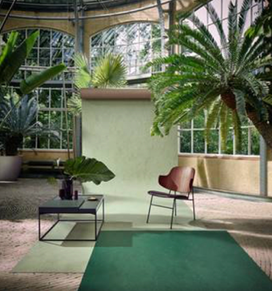 | Marmoleum Marbled in Fresco Hunter Green 3271
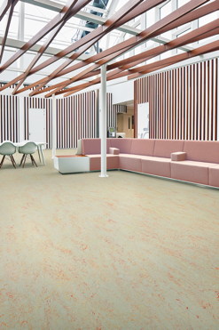 | Marmoleum Marbled in Splash Fruit Punch 3432
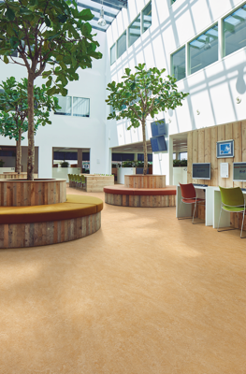 | Marmoleum Marbled in Van Gogh 3173
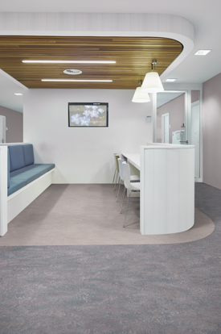 | Marmoleum Marbled in Real Arabesque 3123 and Fresco Lilac 3266

NOT FOR PUBLICATION:
For further press information and approval of colour separation charges, please contact Annabelle Kay at CIB on Tel: 01372 371800, Fax: 01372 371 801 or Email annabellek@cibcomms.co.uk

Please forward all reader enquiries to:
Gerry Cherry
CIB
Riversway
Leatherhead Bridge
Guildford Road
Leatherhead
Surrey
KT22 9AD
Tel: 01372 371800
Fax: 01372 371801
Email: pradmin@cibcomms.co.uk

